Make Your Arrangements Now to Attend!
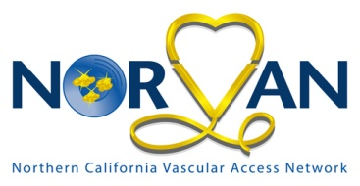
8th Annual Education Day
Presented by NORVAN
Northern California Vascular Access Network
Info@norvan1.org
Date & Location:

Friday April 21st, 2017
Registration 7:45 am - 8:30 am
Program 8:30 am - 3:30 pm

Hilton Sacramento Arden West
2200 Harvard Street,
Sacramento, CA 95815

A limited number of hotel rooms have been reserved at a conference rate, please book your room ASAP.

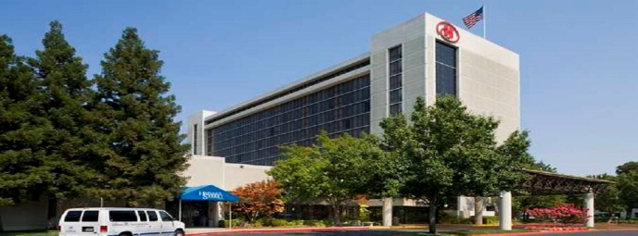
Physicians, Pharmacists, PAs/NPs, and any medical professionals with interest in vascular access are welcomed.

NORVAN Mission Statement
As a local network of the Association of Vascular Access we will continue the vision of providing education and opportunities to improve practice and patient outcomes related to vascular access. By networking within the community we will spread the latest information and best practice guidelines to support and improve patient care in the Northern California area.
Officers: President Michael Bernauer, Presidential Advisor, Treasurer Linda Cole, RN VA-BC, Board Members: Georgia Chaw RN CRNI, Darilyn Cole, RN CRNI VA-BC, Epi Cordero RN BSN VA-BC, Brian Fellmeth PhD MD, Dan Gutierrez, Tony Haskin, RN VA-BC, Mary Claire Miller, BSN MSN CRNI, Stacey Nieporte, Agi Szekacs, RN BRN CCRN VA-BC

PROGRAM PRESENTERS & TOPICS:

Under the Light - NIR
Gregory J Schears, MD
Objectives:
- Describe how NIR imaging systems can be used as a screening tool for vascular pre-assessment.
- Assess vasculature with NIR identifying valves, bifurcations.
- Distinguish good vs. poor vascular access targets

Arterial Infection Prevention
Amy Bardin EdD(c) MS, RRT, VA-BC
Objectives:
- Review literature comparing infection rates with peripheral arterial and central venous catheters.
- Describe recommendations for peripheral arterial catheters with special emphasis on catheter-related infection.
- Discuss strategies for reducing risks associated with peripheral arterial catheters in clinical practice.

Vascular Assessment: Are you doing your due diligence
Rebecca Brestel, RN, BSN, CRNI, VA-BC
Objectives:
- Review the 2016 INS Standards of Care in alignment to vascular access procedures and outcomes.
- Recognize the importance of quality programs in assessing and implementing evidence based practices to vascular access.
- Discuss the challenges of vascular access to capture measurable outcomes in the delivery of quality care.

The Changing Healthcare Landscape: Patient Protection & Affordable Care Act
Renee’ Odehnal, MS, BSN, RN, CRNI, VA-BC
Objectives:
- Describe how the ACA has impacted HAI prevention strategies.
- Identify the best study design to appraise product effectiveness in HAI prevention.
- Discuss how to evaluate product labeling, written claims and verbal clams.
- Describe the changing healthcare landscape, history and HAI impact.

Midline Catheters: Are they safe?
Marcia Ryder, PhD, MS, RN
Objectives:
- Examine the evidence supporting the midline catheter as a safe alternative vascular access device.
- Outline the determining factors in the device selection process for appropriate use of the midline catheter.
- Consider the pathophysiological effects of drug and solution composition on venous pathology.

Early Bird Registration: by March 24th
NORVAN Member: $100
Non Member: $140 (Hint: join NORVAN and save $10)
CVAN/BAVAN Members receive a $15 discount.
RN Student: $60
Regular registration: March 25th - April 10th
NORVAN Members: $125
Non-Members: $165
Late registration: April 11th -19th ALL: $175
Deadline to register: April 19th
No refunds after: April 19th
Light breakfast, lunch and refreshments included.
Register via our website NORVAN1.org

For hotel reservations, contact Hilton Arden West
http://www.hilton.com/en/hi/groups/personalized/S/SMFHIHF-NVN-20170419/index.jhtml
Use group code NVN
Room rates for conference attendees:
Thursday April 20th: $139
Please book your rooms by March 31st

Provider approved by the California Board of Registered Nursing, Provider Number CEP12371 for 6 contact hours.
Contact hours qualify toward VA-BC recertification

7:45AM | 8:30AM | Registration,  Continental Breakfast &  Vendor Displays
8:30AM | 8:45AM | Welcoming Announcement
8:45AM | 9:45AM | Session 1
9:45AM | 10:05AM | Morning Break /  Vendor Displays
10:05AM | 11:05AM | Session 2
11:10AM | 12:10PM | Session 3
12:10PM | 1:00PM | Lunch, Visit Vendor Tables,  Table Service Lunch,  Desert Service in Vendor area,  Door Prizes
1:00PM | 2:00PM | Session 4
2:00PM | 2:15PM | Afternoon Break
2:15PM | 3:15PM | Session 5
3:15PM | 3:30PM | Conclusions, Door Prizes  & Course Evaluations

